Linux Tools

1. Editor in Linux(vi or vim):

* Vim is most popular Editor which is used in Linux and Linux OS.
* Vim is command-oriented editor.
* Vim works in two modes:

1) Insertion and

2) Command.

* Insertion : Whatever we write is displayed on the screen which is editor.
* Command : Command mode contains options for control.

Ex, :wq – save and quit

:q – quit

:q! – quit without saving

:clear – for clearing the file

:wq – save and quit

* To open a file in vim : vim filename.c
* To write in the file : Press “ I or I ”.
* To close the insert mode : Press “ Esc ”.
* To save and exit the opened file : “ :wq ”.

* When we give vim as a command to terminal then as shown below screen will appear which gives information about version and other commands for help.



* To open a file:



Opened file Day_2_1.c

* To compile c file.



* To run a file.

1. Tools for browsing source code(ctags and cscope): cscope and ctags are source code browsing tools.

* cscope :
* cscope tool is used to examine the symbol of your source code .
* Symbol is variable name, function name, etc in source code.
* To install cscope : sudo apt install cscope
* To check version of cscope : cscope –version
* When we give command to terminal as cscope then it will redirect you to interactive screen which has multiple options to examine the source code file.
* For coming back to screen which contains options press “ tab ”.
* To exit the cscope screen : press “ ctrl+d ”.
* To open cscope options screen:



Screen of cscope options to examine the source code file.

* Searching “a” symbol using cscope:

* After pressing tab cscope is ready to take second command:

* Press ctrl+d to exit the cscope.
* ctags:
* ctags is a programming tool used for software development process in large applications.
* ctags is used in Linux variant operating system.
* It supports many programming languages.

* ctags creates a tag file. This tag file contains the name(object/symbol found in the source file or header file.
* ctags create a file that shows index of objects.
* In ctags locator will locate :

1. Where name(var/fun) is used.
2. Pathname.
3. Line in which name (v/f) is used.
4. Type of v/f.

* The tags file shows the complete information about all the objects which are used in source files and header files.
* ctags internally used as locator.
* Advantages of ctags:

1. ctags provide quick access across the file.
2. It provides complete information name/pathname/function.
3. It tends whether particular name is variable or function.

* Giving command “ctags -R” to the terminal.



As, shown below the command will generate “tags” file.



* Opening tags file.



1. Memory related tools(valgrind):

* valgrind is standard debugger used at runtime to identify errors due to heap memory violation.
* It is also used as a memory profiling tool.
* valgrind shows the memory allocated or de-allocated to a code.



* Compiling file with “gcc filename.c -o filename” and running it using “valgrind ./filename”.

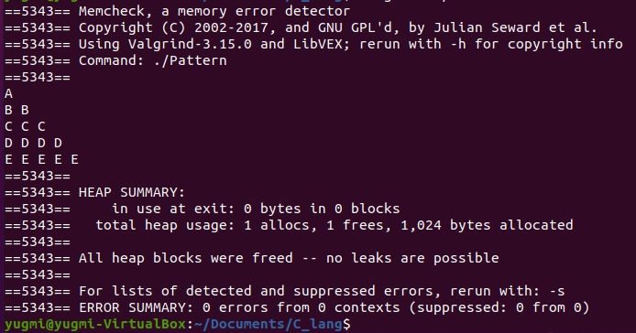

1. Source code versioning tool(GIT , Gerrit) :

* GIT :
* Configuration:

* Gerrit :
* Gerrit is an exceptionally extensible and configurable apparatus for online code survey and storehouse executives for projects utilizing the Git rendition control framework.
* It is used to store the merged code base and the changes under review that have not being merged yet. Gerrit has the limitation of a single repository per project.

1. Debugging tools (GDB) :

* GDB(a GNU debugger) is a powerful debugging tool used for C and C++ programming languages.
* GDB is a free software used with Linux and Linux OS.
* GDB allows the user to stop the program execution in middle of the running and also allows user to probe during the application crash.
* Command to install GDB : sudo apt install gdb
* GDB operates on the executable files which are generated by the compiler. It never work on .c files.
* In GDB, next and step commands are used for debugging.
* Next(n) – Next debugs the next line of the code but Functional lines can’t be debugged using next(n) command.
* Step(s) – It is used to debug the code lines of functions.
* Quit – To quit the debugging “q” command is used.
* To compile the code : gcc -g filename.c -o filename.
* Compiling the code file.



* Running the code.

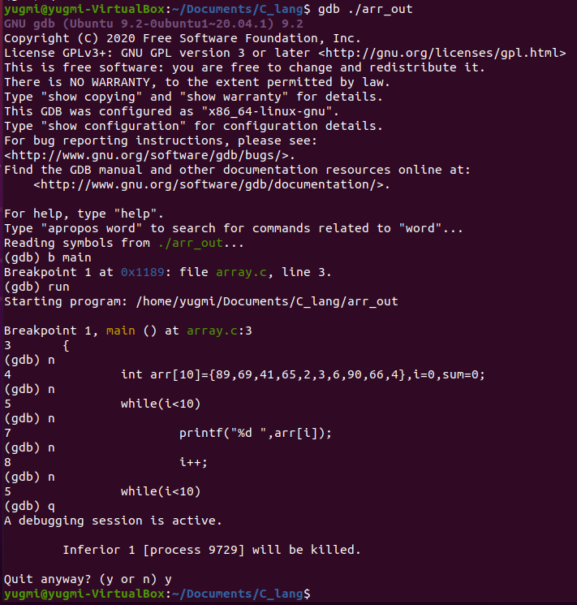

1. Static tools (splint, gcc, clang)